Experiment 1

Harsh Sandesara

Batch C, 45

UID: 2018130045

**Aim:**

To study different types of physical layer wired/wireless connections

**Theory:**

In the seven-layer OSI model of computer networking, the physical layer or layer 1 is the first and lowest layer. It defines the means of transmitting raw bits over a physical data link connecting network nodes. It provides an electrical, mechanical, and procedural interface to the transmission medium. The shapes and properties of the electrical connectors, the frequencies to broadcast on, the line code to use and similar low-level parameters, are specified by the physical layer.

Physical layer elements are broadly classified into two categories: wired and wireless.

*Wired connections:*

1. **USB cable**

USB stands for Universal Serial Bus. It is an industry standard that establishes specifications for cables and connectors. USB cables have plugs, and the corresponding receptacles are on the computers or electronic devices. In common practice, the A end is usually the standard format, and the B side varies over standard, mini, and micro.

* Specifications

*Physical Design:*

* + Based on the physical design of the USB plugs and ports, the three different types are USB A, USB B, and USB C. [1] [2]
  + Based on the functionality of USB connectors, there are three generations of USB cable. The specifications are broken down according to functionality:

*Data transfer rates:* [3]

* USB 1.0 (Low-Speed): 1.5Mbps
* USB 2.0 (Hi-Speed): 480 Mbps
* USB 3.0 (SuperSpeed): 10Gbps

*Range:* [4]

* USB 1: 3 meters (9 feet 10 inches)
* USB 2: 5 meters (16 feet 5 inches)
* USB 3: 3 meters (9 feet 10 inches)

*Compatibility:*

* USB 2 cables are backwards compatible with USB 1 cables; hence they work fine with any USB 1 devices. However, the transfer rates will be limited to the low speeds of USB 1
* USB 3 cables are backwards compatible with USB 1 and USB 2 cables; hence they work fine with any USB 1 or USB 2 devices. However, the transfer rates will be limited to the low speeds of USB 1 or high speeds of USB 2, whichever they are used with

*Power Output:* [5]

* USB 1: 2.5V, 500mA
* USB 2: 2.5V, 1.8A
* USB 3: 5V, 1.8A

*Modulation:*

All functional treatment for needs device control by the help of pulse-width modulation. Currently, due to precise keeping of necessary norms for all suitable kinds of universal serial bus device, a Universal serial bus digital binary values control pulse width modulation utility Device Firmware compatible with most of operating systems is being developed.

* Scalability

The USB is controlled by a host; there can be multiple peripherals but only one host per bus. The host can be taken as master and peripheral as slaves, whereby the former is responsible for managing the connection, transactions, and scheduling bandwidth. The USB system uses tiered start topology. It consists of 7-bit addressing; this means it can support up to 127 devices at once. [7]

As mentioned above, the length of USB cables ranges from 3 to 5 meters. However, using active (repeater) cables can extend the range of use. The maximum recommended lengths of USB repeater cables are as follows:

* USB 1: 18 meters (59 feet) [6]
* USB 2: 30 meters (98 feet 5 inches)
* USB 3: 18 meters (59 feet)

Since USB cables are not very scalable, their use is limited to home applications (Home Area Network or HAN) where they can be used for personal use and device interaction like phone to laptop, laptop to laptop, phone to phone, etc.

* Schematic View

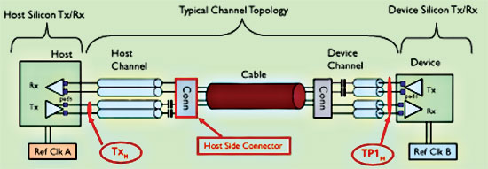

1. **Twisted Pair Copper Cables**

Twisted-pair cable is the most common type of cabling you can see in today's Local Area Networks (LAN) networks. A pair of wires forms a circuit that can transmit data. The pairs are twisted to provide protection against crosstalk. Crosstalk is the undesired signal noise generated by the electromagnetic fields of the adjacent wires. [8]

The two types of twisted pair cables widely used are:

* Unshielded twisted pair:

Unshielded Twisted Pair (UTP) cable is the most common networking media. ‘Unshielded’ meaning it does not rely on physical shielding to block interference. Unshielded Twisted Pair (UTP) consists of four pairs of thin, copper wires covered in color-coded plastic insulation that are twisted together. The wire pairs are then covered with a plastic outer jacket. UTP cables are of small diameter and it does not need grounding.

Since there is no shielding for UTP cabling, it relies only on "cancellation" to avoid noise. It is the more commonly used cable of the two, often utilized for both residential and business use. There are several UTP categories, which increase in bandwidth as you move up the scale, for example: CAT1 = up to 1Mbps | CAT2 = up to 4 Mbps | CAT5e = up to 1Gbps

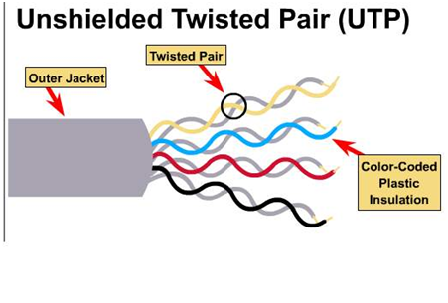

* Shielded twisted pair:

Shielded Twisted Pair (STP) cables additionally have an overall conducting metallic shields covering four twisted pair wires. There may be another conducting metallic shields covering individual twisted pairs also. These metallic shields block out electromagnetic interference to prevent unwanted noise from the communication circuit. Drain wires are also used in Shielded Twisted Pair (STP) cables together with metallic shields for grounding purpose. The drain wire provides a low-resistance connection to shield for better grounding. The main purpose of drain wire is to carry away unwanted interference noise to ground.

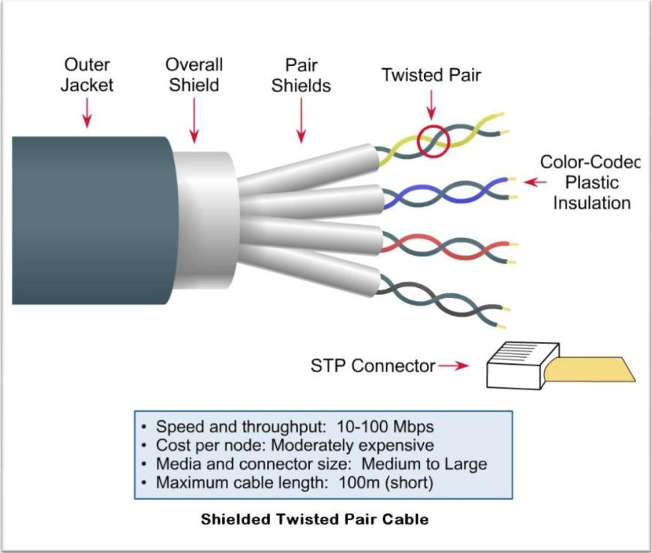

* Specifications

*Range:*

Up to 100 meters

*Bandwidth:*

Up to 750 MHz

*Modulation:*

Line coding is used here. Line coding is the modulation of an electrical charge so that each side of a connection knows what is a one and what is a zero.

*Data Transfer Rates:*

Twisted pair cables can reach transfer rates of over 1000 Mbps (1 Gbps).

* Scalability

It is a scalable LAN architecture.

* Schematic View

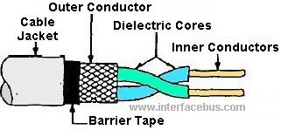

1. **Coaxial Cable**

Coaxial cable is a type of copper cable specially built with a metal shield and other components engineered to block signal interference. It is primarily used by cable TV companies to connect their satellite antenna facilities to customer homes and businesses. It is also sometimes used by telephone companies to connect central offices to telephone poles near customers. Some homes and offices use coaxial cable, too, but its widespread use as an Ethernet connectivity medium in enterprises and data centers has been supplanted by the deployment of twisted pair cabling.

* Specifications

*Types:*

There are several types of coaxial cables, some of which are:

* RG-6: Attenuation, 750 MHz- 5.650db/100ft
* RG-7: Attenuation, 750 MHz- 5.650db/100ft
* RG-8: Attenuation, 750 MHz- 5.967-10.946db/100ft
* RG-11: Attenuation, 750 MHz- 3.650db/100ft
* RG-58: Attenuation, 750 MHz- 13.104db/100ft
* RG-59: Attenuation, 750 MHz- 8.900-9.708db/100ft
* RG-63: Attenuation, 750 MHz- 4.6db/100ft

*Range:*

The range in terms of length of cable to which the signal will be transmitted depends on the frequency of the signal. Typically, a normal Coaxial cable can pass frequencies up to 5GHz. The range can be calculated for each type of cable depending on the attenuation value of the cable type and the frequency that is passed through it.

According to type of cabling, there are two types of cables: ThickNet and ThinNet. The maximum length of ThickNet is 185-200 meters, while that of ThickNet is 500 meters. ThickNet is used as a backbone to connect several smaller ThinNet-based networks.

*Speed:*

There are two Ethernet media standards defined for coaxial cable-based Ethernet. Those standards are 10Base2 and 10Base5.

* 10Base2 has a bandwidth speed of 10 Mbps, to a maximum distance of 200 meters. 10 denotes bandwidth speed and 2 denotes 200 meters.
* 10Base5 has a bandwidth speed of 10 Mbps, to a maximum distance of 500 meters. 10 denotes bandwidth speed and 5 denotes 500 meters.
* Scalability

A single coaxial network can carry about 10,000 voice signals. Coaxial cables are widely used in traditional Ethernet LANs. They are also used in Metropolitan Area Networks (MANs), which means these cables can span a city and its suburbs. They are very scalable. They are used in such applications as telephone trunk lines, broadband internet networking cables, high-speed computer data busses, cable television signals, and connecting radio transmitters and receivers to their antennas.

* Schematic View

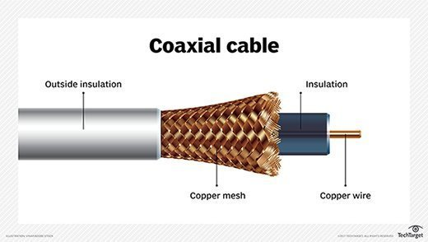

1. **Optical Fiber:**

Optical Fiber cables use optical fibers that carry digital data signals in the form of modulated pulses of light. An optical fiber consists of an extremely thin cylinder of glass, called the core, surrounded by a concentric layer of glass, known as the cladding. There are two fibers per cable—one to transmit and one to receive. The core also can be an optical-quality clear plastic, and the cladding can be made up of gel that reflects signals back into the fiber to reduce signal loss. [13]

* Specifications

There are two types of fiber optic cables: Single Mode Fiber (SMF) and Multi-Mode Fiber (MMF). The specifications of both are as follows:

*Transmission:*

* + Single-mode Fiber (SMF) uses a single ray of light to carry transmission over long distances. [13]
  + Multi-mode Fiber (MMF) uses multiple rays of light simultaneously with each ray of light running at a different reflection angle to carry the transmission over short distances. [13]

*Data Transfer Rates and Range:*

(SMF) can transmit data to distances far more (MMF).

* Data rates of up to 10 gigabits per second were possible at distances of over 80 km (50 mi) with Single Mode Fiber. By using optical amplifiers and dispersion-compensating devices, state-of-the-art DWDM optical systems can span thousands of kilometers at 10 Gbit/s, and several hundred kilometers at 40 Gbit/s. [14]
* Multi-mode fiber cables can transmit data at 100 Mbps (megabits per second) for distances up to 2 kilometers, 1 Gbps up to 1000 meters (1 kilometer), and 10 Gbps up to 550 meters. [13]

*Modulation:*

Optical Fiber uses Fiber Optic Modulation. Fiber-optic communication is a method of transmitting information from one place to another by sending pulses of light through an optical fiber. The light forms an electromagnetic carrier wave that is modulated to carry information. [16]

* Scalability [15]

Depending on the type of fiber optic cable used, segment lengths vary from 150 to 40,000 meters. This limit is due primarily to optical loss, or the degradation of light signal after it travels a certain distance away from its source (just as the light of a flashlight dims after a certain number of feet). Optical loss accrues over long distances and grows with every connection point in the fiber network. Dust or oil in a connection (for example, from people handling the fiber while splicing it) can further exacerbate optical loss. Some types of fiber-optic cable can carry signals 40 miles while others are suited for distances under a mile. The distance a cable can carry light depends partly on the light’s wavelength. It also depends on whether the cable is single mode or multi-mode.

Since their range of use is wide, optical fibres can be used in a lot of applications, ranging from Home Area Networks (HAN) and Local Area Networks (LAN), to Wide Area Networks (WAN).

* Schematic View

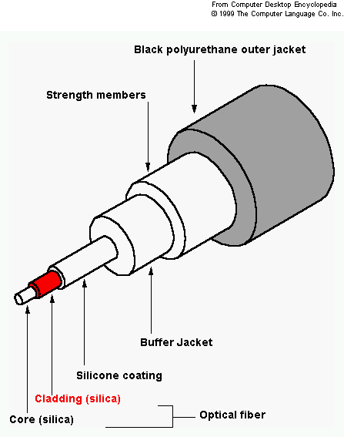

1. **Ethernet**

Ethernet is a family of computer networking technologies commonly used in local area networks (LAN), metropolitan area networks (MAN) and wide area networks (WAN). It is widely used in homes and industry, and interworks well with Wi-Fi. The Internet Protocol is commonly carried over Ethernet and so it is considered one of the key technologies that make up the Internet. [9]

* Specifications

*Range and Speed:*

There are 3 types of Ethernet Networks: 10Base5, 10Base2, and 10BaseT. The range and speeds of each are given below:

The physical medium ranges from bulky coaxial cable to twisted pair and optical fiber with a standardized reach of up to 40 km.

* 10Base5 thick and stiff coaxial cable up to 500 meters (1,600 ft) in length. Up to 100 nodes can be connected to the cable. The data rate is 10 Mbps.
* 10Base2 thin coax cables have a maximum length of 200 metres. The maximum number of nodes that can be connected to it is 30. It offers a 10 Mbps of bandwidth.
* 10BaseT twisted pair of wires and have a maximum length of 100m. Up to 1024 nodes can be connected to it and it offers a bandwidth of 10 Mbps.

The Ethernet physical encompasses multiple physical media interfaces and several orders of magnitude of speed from 1 Mbit/s to 400 Gbit/s.

*Modulation:*

Most forms of Ethernet use pulse amplitude modulation (PAM) constellations. In PAM signal modulation, information is encoded in the amplitude of a series of signal pulses.

* Scalability [10]

Ethernet is a communication protocol for Local Area Network (LAN) using same media interfaces (mainly RJ45 or fiber). LAN are independent networks but may be linked within a WAN through Internet devices such as Routers.

Ethernet has lasted well since its inception in the 1970s with Ethernet frame-structure and addressing remaining ubiquitous in the data centre environment as in many others. However, Ethernet exhibits scalability issues when used to build broadcast domains of more than a few thousand devices, such as costly and energy-dense address table logic and storms of broadcast traffic. The traditional method of avoiding such problems is the artificial subdivision of a network, but this introduces an administrative burden, requires significant routing equipment and with current protocols also precludes live migration.

* Schematic View

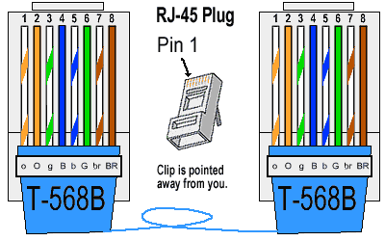

1. **Fiber Distributed Data Interface**

Fiber Distributed Data Interface (FDDI) is a standard for data transmission in a local area network. It uses optical fiber as its standard underlying physical medium, although it was also later specified to use copper cable, in which case it may be called CDDI (Copper Distributed Data Interface). [11]

* Specifications

*Medium:*

FDDI uses optical fiber as its physical medium.

*Range:*

200 kilometers

*Bandwidth:*

100Mbps

*Data Transfer Rate:*

FDDI can transport data at a rate of 100 Megabits per second.

*Stations:*

FDDI can support up to 500 stations on a single network.

*Modulation:*

FDDI Transmission on optical fiber is done through Intensity Modulation, that is, the optical power output of a source is varied in accordance with some characteristic of the modulating signal.

* Scalability [12]

Fiber Distributed Data Interface (FDDI) is usually implemented as a dual token-passing ring within a ring topology (for campus networks) or star topology (within a building). It is applicable in large LANs that can extend up to 200 kilometers in diameter. FDDI is not often used as a wide area network (WAN) solution but is more often implemented in campus-wide networks as a network backbone. Typically, a computer-room contained the whole dual ring, although some implementations deployed FDDI as a metropolitan area network.

FDDI was effectively made obsolete in local networks by Fast Ethernet which offered the same 100 Mbit/s speeds, but at a much lower cost and, since 1998, by Gigabit Ethernet due to its speed, and even lower cost, and ubiquity.

* Schematic View

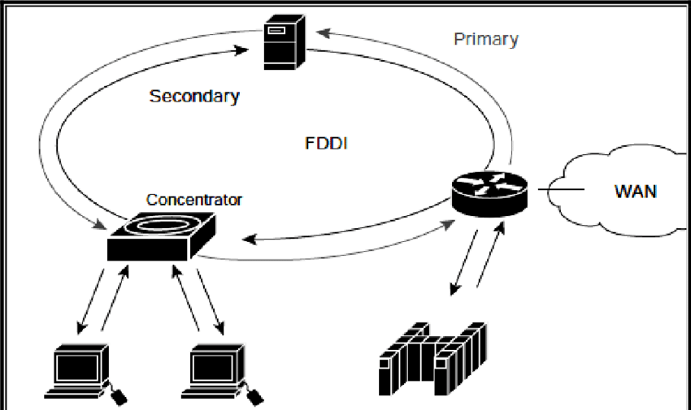

*Wireless connections:*

1. **Infrared networking**

Infrared (IR) is a wireless mobile technology used for device communication over short ranges. IR communication has major limitations because it requires line-of-sight, has a short transmission range and is unable to penetrate walls. IR transceivers are quite cheap and serve as short-range communication solutions. [13]

* Specifications

*Range:*

Infrared communications span only short distances.  When networking two infrared devices, they must be within a few feet of each other. Unlike Wi-Fi and Bluetooth technologies, infrared network signals cannot penetrate walls or other obstructions and work only within a direct line of sight. Anything that blocks that direct line between two IR devices also blocks IR communication.

*Modulation:*

All modern infrared remote-control designs use digital modulation. Two basic digital modulation technologies are Amplitude Shift Keying (ASK) and Frequency Shift Keying (FSK). ASK represents logic 1 and 0 by changing the carrier amplitude, and FSK represents these logic levels using two different carrier frequencies.

*Security:*

Infrared communication has high directionality and can identify the source as different sources emit radiation of different frequencies and thus the risk of information being diffused is eliminated.

*Data Transfer Rate:* [15]

Infrared technology uses in local networks exists in three forms that the Infrared Data Association (IrDA) recognizes:

* IrDA-SIR: Slow-speed infrared that supports data rates up to 115 Kbps.
* IrDA-MIR: Medium-speed infrared that supports data rates up to 1.15 Mbps.
* IrDA-FIR: High-speed infrared that supports data rates up to 4 Mbps.

*Usage:*

Computer infrared network adapters both transmit and receive data through ports on the rear or side of a device. Many laptops and personal hand-held devices had infrared adapters installed.

Infrared networks support direct two-computer connections only. Extensions to infrared technology, however, support more than [two computers](https://www.lifewire.com/connecting-home-computers-for-file-sharing-817713) and semi-permanent networks.

* Scalability [14] [16]

Infrared communications span only short distances of up to two feet and can only be successfully implemented when there is no object blocking the direct line between the two IR devices. As such, Infrared technology is not scalable and is only used in home applications (HAN).

* Schematic View

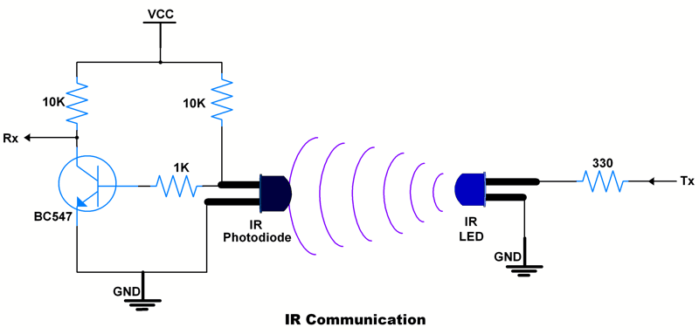

1. **Z Wave**

Z Wave is a wireless communications protocol used primarily for home automation. It is a mesh network using low-energy radio waves to communicate from appliance to appliance, allowing for wireless control of residential appliances and other devices, such as lighting control, security systems, thermostats, windows, locks, swimming pools and garage door openers. [18]

* Specifications

*Latency:*

Low latency transmission of small data packets (data rates up to 100kbit/s)

*Range of use:*

About 30 meters between nodes (40 meters with 500 series chip), message ability to hop up to four times between nodes, giving enough coverage for most residential houses

*Modulation:*

Modulation is frequency-shift keying (FSK) with Manchester encoding

*Frequency of operation:*

868.42 MHz in Europe, at 908.42 MHz in North America, 865.2 MHz in India

*Throughput:*

40kbit/s, suitable for control and sensor applications

*Data rates*:

Include 9600 bps and 40 kbps with output power at 1mW or 0 dBm

* Scalability

Z-Wave can be used within a network (Home Area Network or HAN) and can therefore be used to set up all areas of home automation. Possibly controlled by a single controller.

A mesh topology allows any node to connect to any other node and allows multiple connections.

A node must be in the range of another node and can communicate with adjacent nodes. A packet can hop over 4 nodes which effectively limits the distance between a controller and the farthest node.

A node can forward packets to the adjacent nodes. However, to act as a forwarding node the node must be mains powered. Battery-powered nodes cannot forward packets.

* Schematic View

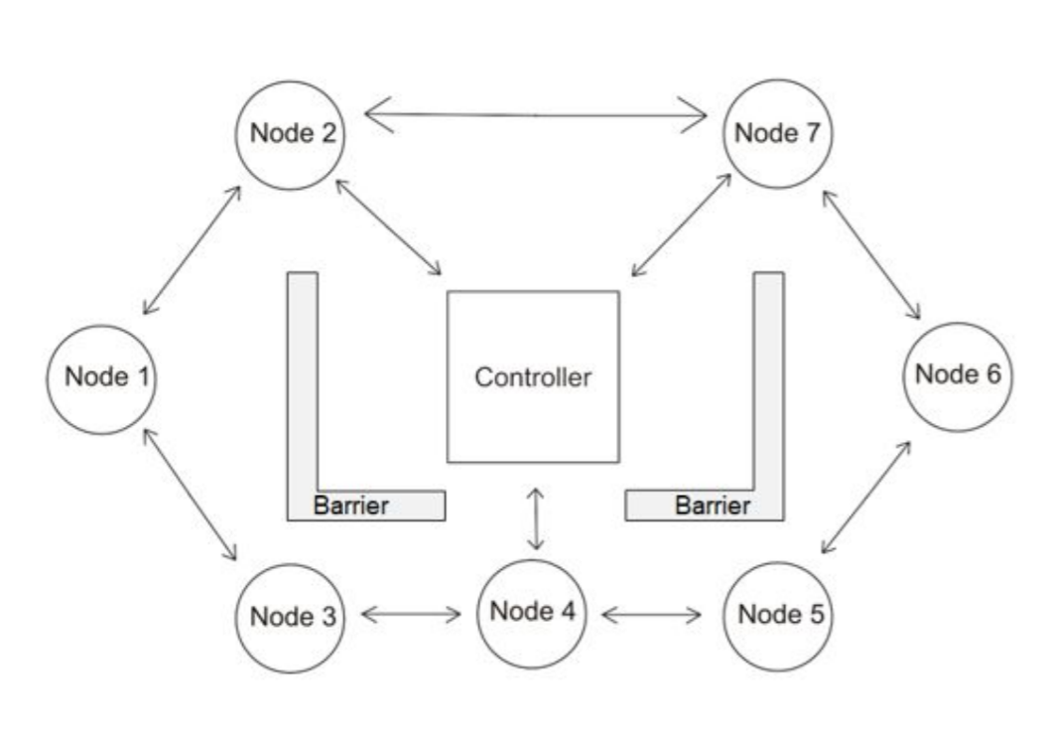

1. **Li-Fi**

Li-Fi (short for light fidelity) is wireless communication technology which utilizes light to transmit data and position between devices. In technical terms, Li-Fi is a light communication system that is capable of transmitting data at high speeds over the visible light, ultraviolet, and infrared spectrums. In its present state, only LED lamps can be used for the transmission of visible light. [19]

* Specifications

*Spectrum:*

Li-Fi uses visible light of electromagnetic spectrum between 400 THz and 800 THz as optical carrier for data transmission and illumination.

*Data Transfer:*

Communication rate more than 100 Mbps can be achieved by using high speed LEDs with the help of various multiplexing techniques. And this VLC data rate can be further increased to as high as 10 Gbps via parallel data transmission using an array of LED lights with each LED transmitting a different data stream.

*Layers:*

IEEE 802.15.7 defines physical layer (PHY) & media access control (MAC) layer for VLC/Li-Fi.

*Modulation:* [20]

The physical layer is divided into 3 types: PHY I, II, III and employ a combination of different modulation schemes.

* The PHY I was established for outdoor application and works from 11.67 kbps to 267.6 kbps.
* The PHY II layer permits reaching data rates from 1.25 Mbit/s to 96 Mbit/s.
* The PHY III is used for many emissions sources with a modulation method called colour shift keying (CSK). PHY III can deliver rates from 12 Mbit/s to 96 Mbit/s.
* The modulation formats recognized for PHY I and PHY II are on-off keying (OOK) and variable pulse position modulation (VPPM).
* The Manchester coding used for the PHY I and PHY II layers includes the clock inside the transmitted data by representing a logic 0 with an OOK symbol "01" and a logic 1 with an OOK symbol "10", all with a DC component.
* The DC component avoids light extinction in case of an extended run of logic 0's.

*Range:*

Light waves do not penetrate through walls and so Li-Fi has a much shorter range than Wi-Fi. The main purpose of VLC standard is to focus on medium-range communications for intelligent traffic systems at low-speed and on shortrange mobile to mobile and fixed to mobile communications at high speeds to exchange data. The range of Li-Fi depends on Light Intensity. It has a range of around 10 meters.

* Scalability [21]

Li-Fi provides a stable data rate per user, providing robust, reliable wireless communication – something that Wi-Fi can struggle with as the radio spectrum becomes congested. Li-Fi provides an extra level of security as light cannot penetrate walls. The connection must be within line of sight and is enabled with a personal USB access key. Li-Fi offers scalable capabilities for up to 15 users within the coverage beam of one light point.

Since access to a Li-Fi channel is limited to devices inside the room, it is predicted to mainly be used in future home applications. Hence, Li-Fi is a Home Area Network (HAN) interface. However, with new research going on, the applications can extend to vehicles, industrial and building automation, underwater applications, aviation, hospitals, advertising, and education.

* Schematic View

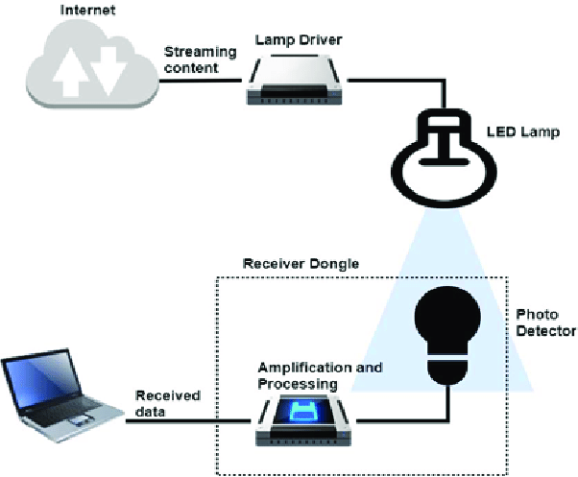

1. **Wi-Fi (WLAN)**

A wireless LAN (WLAN) is a wireless computer network that links two or more devices using wireless communication to form a local area network (LAN) within a limited area such as a home, school, computer laboratory, campus, or office building. This gives users the ability to move around within the area and remain connected to the network. Most modern WLANs are based on IEEE 802.11 standards and are marketed under the Wi-Fi brand name. [22]

* Specifications

*Range:*

Within a limited area such as a home, school, computer laboratory, campus, or office building. A typical wireless router in an indoor point-to-multipoint arrangement using 802.11n and a stock antenna might have a range of 50 meters (160 ft) or less. Outdoor point-to-point arrangements, through use of directional antennas, can be extended with many kilometers between stations. [22]

*Modulation:* [23]

Wi-Fi systems use two primary radio transmission techniques:

* + 802.11b (<=11 Mbps):

The 802.11b radio link uses a direct sequence spread spectrum technique called complementary coded keying (CCK). The bit stream is processed with a special coding and then modulated using Quadrature Phase Shift Keying (QPSK).

* + 802.11a and g (<=54 Mbps):

The 802.11a and g systems use 64-channel orthogonal frequency division multiplexing (OFDM). In an OFDM modulation system, the available radio band is divided into several sub-channels and some of the bits are sent on each. The transmitter encodes the bit streams on the 64 subcarriers using Binary Phase Shift Keying (BPSK), Quadrature Phase Shift Keying (QPSK), or one of two levels of Quadrature Amplitude Modulation (16, or 64-QAM). Some of the transmitted information is redundant, so the receiver does not have to receive all the sub-carriers to reconstruct the information.

Wi-Fi uses adaptive modulation and varying levels of forward error correction to optimize transmission rate and error performance. As a radio signal loses power or encounters interference, the error rate will increase. Adaptive modulation means that the transmitter will automatically shift to a more robust, though less efficient, modulation technique in those adverse conditions.

*Frequencies:*

Various frequencies, including, but not limited to, 2.4 GHz, 5 GHz, 6 GHz, and 60 GHz frequency bands. [24]

*Data Transfer Rates*

* + 802.11b:

1, 2, 5.5, 11Mbps

* + 802.11a:

6, 9, 12, 18, 24, 36, 48, 54 Mbps

* + 802.11g:

Varying modulation types: 6, 9, 12, 18, 24, 36, 48 and 54 Mbps; can revert to 1, 2, 5.5, and 11 Mbps using DSSS and CCK.

* + 802.11n:

1, 2, 5.5, 6, 9, 11, 12, 18, 24, 36, 48, 54 Mbps

* Scalability [25]

Wi-Fi is intended for LAN applications, users scale from one to tens with one subscriber for each CPE device. Fixed channel sizes (20MHz). It has a limited area to cover. When Wi-Fi is scaled beyond Local Area Network, several problems arise:

* + WLAN uses radio frequency which can interfere with other devices which use radio frequency.
  + The radiation of WLAN can be harmful to the environment.
  + If there is rain or thunder, then communication may get interrupted.
  + Signals may be affected by the environment as compared to using fiber optics.
* Schematic View

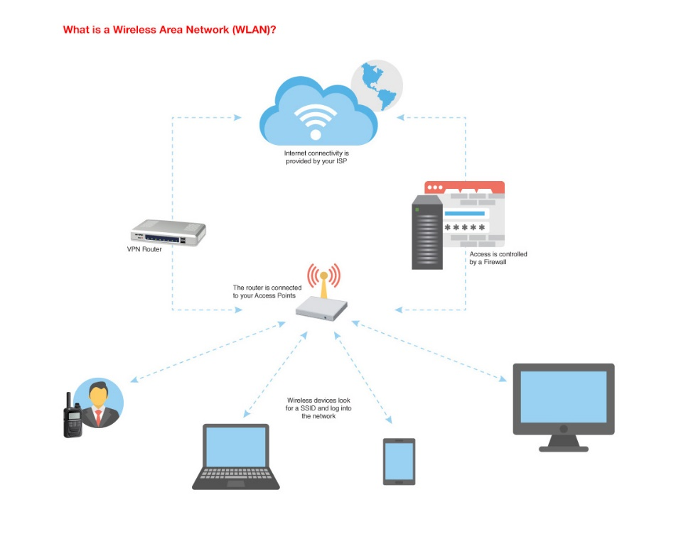

1. **Bluetooth**

Bluetooth is a wireless technology standard used for exchanging data between fixed and mobile devices over short distances using short-wavelength UHF radio waves in the industrial, scientific and medical radio bands, from 2.402 GHz to 2.480 GHz, and building personal area networks (PANs). [34]

* Specifications

*Range:*

The range of Bluetooth is typically less than 10 meters (33 feet). However, the new Bluetooth technology (Bluetooth 5.0) may have range from 40 to 400 meters (100-1000 feet).

*Speed:*

Bluetooth speeds are continuously increasing with every generation. Initially, the speeds were as low as 721 kbps in practice. However, now the speeds go as high as 2 Mbps.

*Modulation:*

Bluetooth uses Gaussian frequency shift keying (GFSK). Frequency shift keying encodes data as a series of frequency changes in a carrier wave. GFSK differs from simple FSK in that before the signal is passed through the FSK modulator, it is passed through a Gaussian filter to make the transitions smoother to limit its spectral width. [34]

* Scalability

Bluetooth it typically used in WPAN (Wireless Personal Area Network) to transfer data between devices. The network connection style used in classic Bluetooth is a traditional point-to-point connection that looks like a star topology. The central device, for example a smartphone, can be paired with several devices, like headphones, smartwatch, fitness bands and other small devices. However, in 2016, with the introduction of Bluetooth 5 there was the development of a new connectivity model – Mesh network. It enables many-to-many style of communication with multiple potential paths between nodes to ensure delivery. It operates on the flood network principle. It can support a maximum of 32767 nodes.

* Schematic View

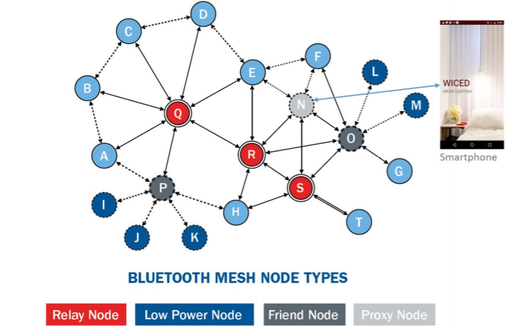

1. **ZigBee**

Zigbee is an IEEE 802.15.4-based specification for a suite of high-level communication protocols used to create personal area networks with small, low-power digital radios, such as for home automation, medical device data collection, and other low-power low-bandwidth needs, designed for small scale projects which need wireless connection. Hence, Zigbee is a low-power, low data rate, and proximity (i.e., personal area) wireless ad hoc network. [36] [38]

* Specifications

*Range:*

Its low power consumption limits transmission distances to 10–100 meters line-of-sight, depending on power output and environmental characteristics. Zigbee devices can transmit data over long distances by passing data through a mesh network of intermediate devices to reach more distant ones. [36]

*Data Transfer Rate:*

ZigBee's data transfer speed is lower than Wi-Fis. Its maximum speed is just 250kbps, much lower than the lowest speed Wi-Fi offers.

*Modulation:*

The radios use direct sequence spread spectrum coding, which is managed by the digital stream into the modulator. Binary phase-shift keying (BPSK) is used in the 868 and 915 MHz bands, and offset quadrature phase-shift keying (OQPSK) that transmits two bits per symbol is used in the 2.4 GHz band.

*Bandwidth:*

The Zigbee standard operates on the IEEE 802.15.4 physical radio specification and operates in unlicensed bands including 2.4 GHz, 900 MHz, and 868 MHz

* Scalability [36]

The Zigbee network layer natively supports both star and tree networks, and generic mesh networking. Every network must have one coordinator device. Within star networks, the coordinator must be the central node. Both trees and meshes allow the use of Zigbee routers to extend communication at the network level. In a mesh network, nodes are interconnected with other nodes so that multiple pathways connect each node. Another defining feature of Zigbee is facilities for carrying out secure communications, protecting establishment and transport of cryptographic keys, ciphering frames, and controlling device.

Mesh networks are decentralized in nature; each node is capable of self-discovery on the network. Also, as nodes leave the network, the mesh topology allows the nodes to reconfigure routing paths based on the new network structure. The characteristics of mesh topology and ad-hoc routing provide greater stability in changing conditions or failure at single nodes.

The Zigbee network specification states that networks can theoretically scale to thousands of nodes per network. However, realistically, and in practice, Zigbee networks can scale to hundreds of nodes in a single network. Our point-to-point/Bluetooth option is limited to two nodes and Wi-Fi to 15 devices per access point.

Since the range of Zigbee interface is 10-100 meters line-of-sight, it is mostly used in Home Area Networks (HAN) and a few other industry-level networks. Applications include wireless light switches, home energy monitors, traffic management systems, and other consumer and industrial equipment that requires short-range low-rate wireless data transfer.

* Schematic View [37]

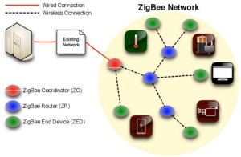

1. **Near Field Communication**

NFC stands for ‘Near Field Communication’ and, as the name implies, it enables short-range communication between compatible devices. This requires at least one transmitting device, and another to receive the signal. A range of devices can use the NFC standard and will be considered either passive or active. [40]

* Specifications

*Range:*

NFC has a very low range— about 4cm (1 ½ in) or less. NFC is included in Body Area Network (BAN), and sometimes has its own spatial scope, sitting between BAN and Nanoscale. [39]

*Data Transfer Rates:*

NFC offers a low-speed connection with a simple setup. It has a data transfer rate of 106 to 424 kbps. [39]

*Modulation:*

NFC employs two different coding to transfer data. If an active device transfers data at 106 kbps, a modified Miller coding with 100% modulation is used. In all other cases Manchester coding is used with a modulation ratio of 10%. [39]

* Scalability

NFC has small applications like mobile identification, mobile payments etc. Also, NFC chips can be used to automate small tasks on devices. Since NFC utilizes point-to-point network topology between 2 devices it is not scalable to larger networks. [39]

As mentioned above, NFC sometimes has its own spatial scope, between Body Area Network (BAN) and Nanoscale.

* Schematic View

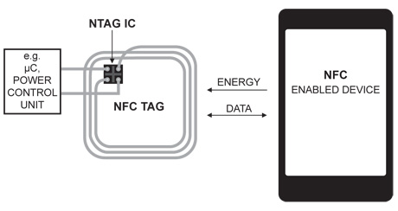

1. **4G LTE**

LTE is an abbreviation for Long Term Evolution. LTE is a 4G wireless communications standard developed by the 3rd Generation Partnership Project (3GPP) that is designed to provide up to 10x the speeds of 3G networks for mobile devices such as smartphones, tablets, netbooks, notebooks, and wireless hotspots. [41]

* Specifications

*Speed:*

In 2019, OpenSignal's The State of LTE report said LTE continues to expand and see global strength. Speeds greater than 50 Mbps can be found in the most advanced LTE countries, while the U.S. averages 21.3 Mbps and most countries fall between 10 and 20 Mbps. [41]

*Range:*

LTE is required to support communication with terminals moving at speeds of up to 350 km/h or even up to 500 km/h depending on the frequency band.

*Modulation:*

LTE uses Orthogonal Frequency Division Multiplexing (OFDM) for the downlink - that is, from the base station to the terminal to transmit the data over many narrow band careers of 180 KHz each instead of spreading one signal over the complete 5MHz career bandwidth. [42]

* Scalability

LTE can manage fast-moving mobiles and supports multi-cast and broadcast streams. LTE supports scalable carrier bandwidths, from 1.4 MHz to 20 MHz and supports both frequency division duplexing (FDD) and time-division duplexing (TDD). The IP-based network architecture, called the Evolved Packet Core (EPC) designed to replace the GPRS Core Network, supports seamless handovers for both voice and data to cell towers with older network technology such as GSM, UMTS and CDMA2000. [43]

* Schematic View [44]

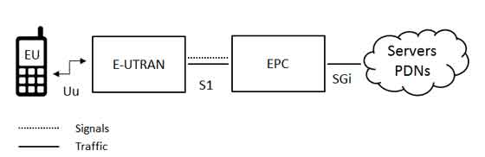

1. **WiMAX (802.16)**

WiMAX (Worldwide Interoperability for Microwave Access) is one of the hottest broadband wireless technologies around today. WiMAX systems are expected to deliver broadband access services to residential and enterprise customers in an economical way. [45]

* Specifications

*Data Transfer Rates:*

WiMAX was initially designed to provide 30 to 40 megabit-per-second data rates, with the 2011 update providing up to 1 Gbit/s for fixed stations. [46]

*Range:*

WiMAX cannot deliver 70 Mbps over 50 km (31 mi). Like all wireless technologies, WiMAX can operate at higher bitrates or over longer distances but not both. Operating at the maximum range of 50 km (31 mi) increases bit error rate and thus results in a much lower bitrate. Conversely, reducing the range (to under 1 km) allows a device to operate at higher bitrates. [46]

*Modulation:*

WiMAX supports a variety of modulation and coding schemes and allows for the scheme to change on a burstby-burst basis per link, depending on channel conditions. Downlink: BPSK, QPSK, 16 QAM, 64 QAM; BPSK optional for OFDMA-PHY. Uplink: BPSK, QPSK, 16 QAM; 64 QAM optional.

* Scalability

WiMAX is scalable to LAN and WMAN. The scalable physical layer architecture that allows for data rate to scale easily with available channel bandwidth and range of WiMAX make it suitable for the following potential applications:

* Providing portable mobile broadband connectivity across cities and countries through various devices.
* Providing a wireless alternative to cable and digital subscriber line (DSL) for "last mile" broadband access.
* Providing data, telecommunications (VoIP) and IPTV services (triple play).
* Providing Internet connectivity as part of a business continuity plan.
* Smart grids and metering. [46]
* Schematic View

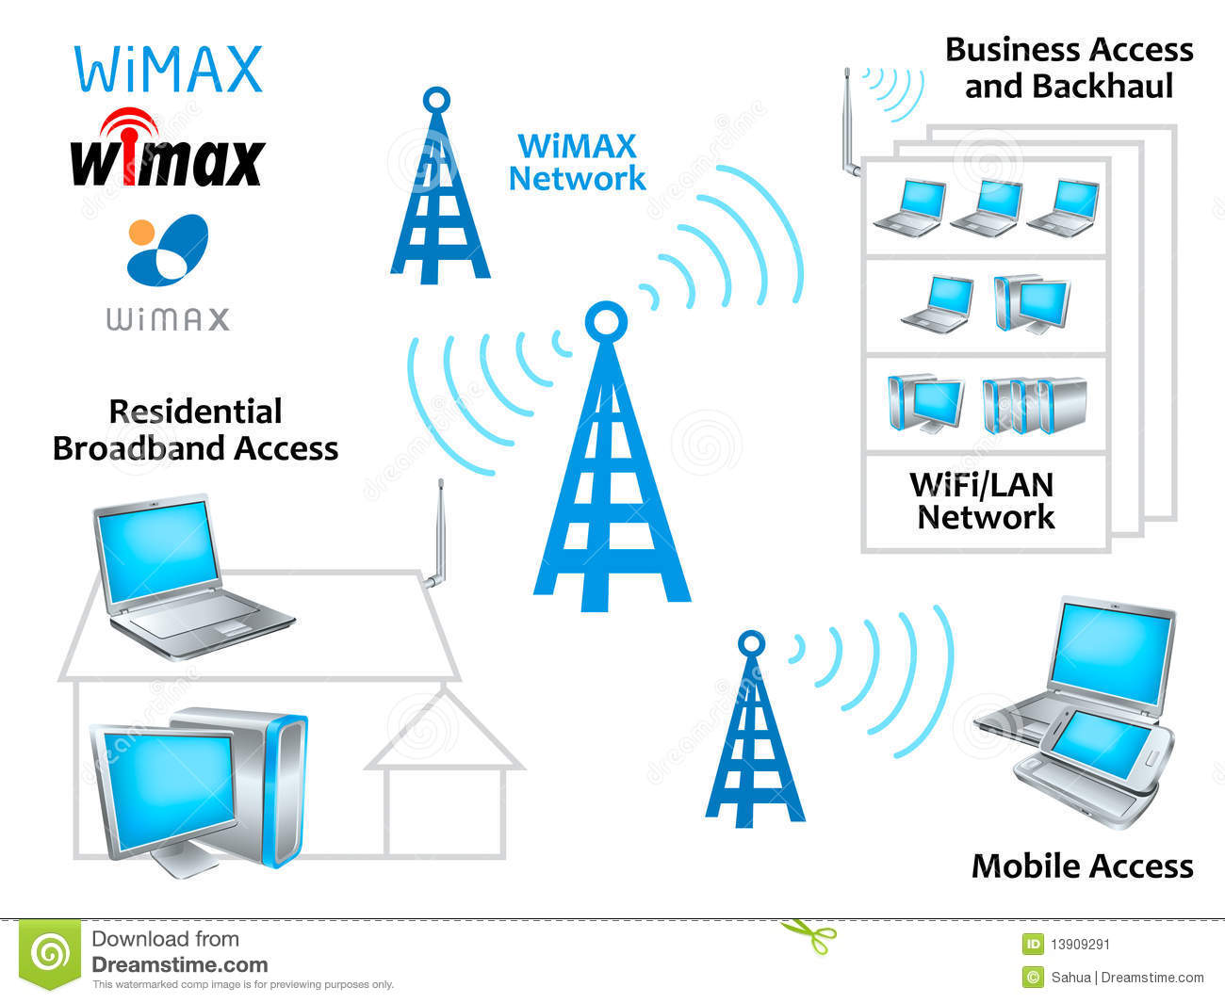

1. **Starlink Satellite Constellation** [47]

Starlink is a satellite constellation development project underway by SpaceX, to develop a low-cost, high-performance satellite bus and requisite customer ground transceivers to implement a new spaceborne Internet communication system. The constellation will consist of thousands of mass-produced [small satellites](https://en.wikipedia.org/wiki/Small_satellite) in [low Earth orbit](https://en.wikipedia.org/wiki/Low_Earth_orbit) (LEO), working in combination with ground [transceivers](https://en.wikipedia.org/wiki/Transceiver).

[Product development](https://en.wikipedia.org/wiki/Product_development) began in 2015, with the first two prototype [test-flight](https://en.wikipedia.org/wiki/Flight_test) satellites launched in February 2018. A second set of test satellites and the first large deployment of a piece of the constellation occurred in May 2019 when the first 60 operational satellites were launched. The [first 60 Starlink satellites](https://www.space.com/spacex-launches-60-starlink-internet-satellites.html) were launched on May 23, 2019, aboard a SpaceX [Falcon 9 rocket](https://www.space.com/18962-spacex-falcon-9.html). The satellites successfully reached their operational altitude of 340 miles (550 kilometers) — low enough to get pulled down to Earth by atmospheric drag in a few years so that they don't become space junk once they die.  As of 2020, SpaceX is launching 60 satellites at a time, aiming to deploy 1,584 of the 260 kilograms (570 lb) spacecraft to provide near-global service by late 2021 or 2022.[[10]](https://en.wikipedia.org/wiki/Starlink#cite_note-10) SpaceX is targeting a private beta service in the [Northern United States](https://en.wikipedia.org/wiki/Northern_United_States) and [Canada](https://en.wikipedia.org/wiki/Canada) by August 2020 with a public beta following in November 2020, service beginning at high latitudes between 44°-52° North. [49]

* Specifications [50]

*Speed and Latency:*

According to SpaceX, Starlink will offer speeds of up to a gigabit per second at latencies from 25 milliseconds to 35 milliseconds.

Those latencies would make SpaceX's service comparable to cable and fiber, while existing satellite broadband services have latencies of 600 ms or more, [according to FCC measurements](https://www.fcc.gov/reports-research/reports/measuring-broadband-america/measuring-broadband-america-2015).

*Range:*

[In a filing to the Federal Communications Commission](https://licensing.fcc.gov/cgi-bin/ws.exe/prod/ib/forms/attachment_menu.hts?id_app_num=128513&acct=599269&id_form_num=15&filing_key=-425955) (FCC), SpaceX is asking the agency to modify its license so that more than 1,500 Starlink satellites can operate at an altitude 600 kilometers lower than the company originally requested.

*Modulation:*

Each Starlink satellite will communicate with four other satellites using lasers. That means they will beam data across the globe at almost the speed of light—a speed that only fiber-optic internet comes close to matching.

* Scalability

Starlink satellites will sit closer to the Earth to reduce latency and use lasers to boost internet speeds. Starlink satellites will sit about 342 miles above the Earth’s surface.4 That’s *much* closer than other satellites, which means there is much less distance for your internet signal to travel to a Starlink satellite.

*Keeping space clean* [48]

SpaceX says moving the satellites to a lower altitude means it can do more with less.

Lower altitude makes it easy to dispose of these satellites once they’re done in space. At this height, particles from Earth’s atmosphere bombard the spacecraft more rapidly, pushing them out of orbit and dragging them down to the planet. And on the way down, they burn up in the atmosphere.

Making sure these spacecrafts come out of orbit in a timely manner is crucial because of the vast number of vehicles that SpaceX wants to put into orbit. A constellation the size of Starlink could dramatically increase the number of operational satellites in space, raising the risk of in-space collisions. [A recent NASA study](https://www.theverge.com/2018/9/28/17906158/nasa-spacex-oneweb-satellite-large-constellations-orbital-debris) argued that 99 percent of these satellites will need to be taken out of orbit, reliably, within five years of launch, or the risk of satellite collisions goes up quite a bit.

The atmosphere at 550 kilometers should do the job within a few years. This is helpful in case the spacecraft fails in orbit. Satellites that fail in higher altitudes could turn into unoperational space debris that stay in orbit for long periods of time. At lower altitudes, they can still fail, and the atmosphere will still swallow them up in a timely manner.

* Schematic View

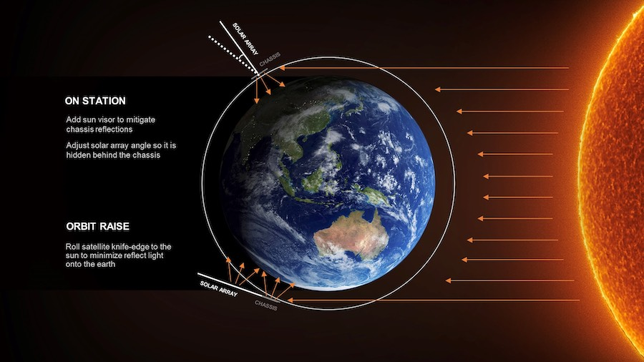

**Conclusion:**

* I have researched about the various types of wired and wireless physical interfaces.
* Based on range, data transfer rates, scalability and network architecture, there is a wide variety of physical interfaces available, which cater to almost every type of application.
* Some technologies have become obsolete because of the discovery of newer and better technologies, and research is being done on even better network interfaces. This shows that this field is continuously evolving.

**References:**

1. <https://www.scienceabc.com/innovation/usb-type-c-different-usb-type-type-b.html>
2. <http://www.differencebetween.info/difference-between-type-a-b-and-c-usb-cable#:~:text=Key%20Difference%3A%20Type%20A%2C%20B%20or%20C%20usually,has%20probably%20moved%20on%20to%20something%20more%20advanced>.
3. <https://www.sony.com/electronics/support/articles/00024571>
4. <http://www.yourcablestore.com/USB-Cable-Length-Limitations-And-How-To-Break-Them_ep_42-1.html#:~:text=You%20can%20use%20a%20regular%20USB%20cable%20in,devices.%20Note%3A%20Typically%2C%20active%20cables%20are%20bus-powered%20cables>.
5. <https://helpdeskgeek.com/networking/usb-cable-types-explained-versions-ports-speed-and-power/>
6. <http://www.yourcablestore.com/USB-Cable-Length-Limitations-And-How-To-Break-Them_ep_42-1.html#:~:text=You%20can%20use%20a%20regular%20USB%20cable%20in,devices.%20Note%3A%20Typically%2C%20active%20cables%20are%20bus-powered%20cables>.
7. <https://www.engineersgarage.com/tutorials/introduction-to-usb-advantages-disadvantages-and-architecture-part-1-6/>

*Twisted Copper Cables:*

1. <https://www.omnisecu.com/basic-networking/common-network-cable-types.php#:~:text=Twisted%20pair%20cables%20have%20different%20categories.%20Each%20category,transfer%20rates%20of%20over%201000%20Mbps%20%281%20Gbps%29.>
2. <https://searchnetworking.techtarget.com/definition/coaxial-cable-illustrated>
3. <https://en.wikipedia.org/wiki/Coaxial_cable>
4. <https://www.tutorialspoint.com/Coaxial-Cable>
5. <https://www.omnisecu.com/basic-networking/common-network-cable-types.php>
6. <https://www.omnisecu.com/basic-networking/common-network-cable-types.php>
7. <https://en.wikipedia.org/wiki/Single-mode_optical_fiber>
8. <http://www.fiber-optic-tutorial.com/the-characteristics-and-benefits-of-fiber-optic-cables.html#:~:text=Size%20and%20scalability%20%E2%80%93%20Depending%20on%20the%20type,flashlight%20dims%20after%20a%20certain%20number%20of%20feet%29.>
9. http://en.wikipedia.org/wiki/fiber-optic_communication#:~:text=Fiber-optic%20communication%20is%20a%20method%20of%20transmitting%20information,carrier%20wave%20that%20is%20modulated%20to%20carry%20information.
10. <https://www.amphenol-socapex.com/en/what-difference-between-internet-and-ethernet-between-lan-and-wan>
11. <https://en.wikipedia.org/wiki/Ethernet>
12. <http://web.cs.wpi.edu/~rek/Grad_Nets/Spring2013/FDDI_S13.pdf>
13. <https://en.wikipedia.org/wiki/Fiber_Distributed_Data_Interface>
14. <https://www.techopedia.com/definition/630/infrared-ir>
15. <https://www.lifewire.com/definition-of-infrared-817726#:~:text=What%20Is%20Infrared%20Networking%20and%20How%20Does%20It,rates%20up%20to%201.15%20Mbps.%20More%20items...%20>
16. <https://www.ti.com/lit/an/slaa644b/slaa644b.pdf#:~:text=All%20modern%20infrared%20remote%20control%20designs%20use%20digital,using%20two%20different%20carrier%20frequencies.%202.1%20ASK%20Modulation>
17. <https://www.elprocus.com/communication-using-infrared-technology/>
18. <https://en.wikipedia.org/wiki/Z-Wave>
19. <https://stevessmarthomeguide.com/z-wave-basics/>
20. <https://en.wikipedia.org/wiki/Li-Fi>
21. <https://www.tec.gov.in/pdf/Studypaper/lifi%20study%20paper%20-%20approved.pdf#:~:text=Being%20a%20Visible%20Light%20Communication%20%28VLC%29%2C%20Li-Fi%20uses,of%20light%20to%20transmit%20information%20in%20wireless%20medium.>
22. <https://disruptionhub.com/future-of-connectivity-lifi/>
23. <https://en.wikipedia.org/wiki/Long-range_Wi-Fi#:~:text=%20Increasing%20range%20in%20other%20ways%20%201,make%20them%20more%20suitable%20for%20long...%20More%20>
24. <https://www.intel.com/content/www/us/en/support/articles/000005725/network-and-i-o/wireless.html>
25. <https://www.tutorialspoint.com/wimax/wimax_wifi_comparison.htm#:~:text=Scalability%20Wi-Fi%20is%20intended%20for%20LAN%20applications%2C%20users,equipments%20%28CPE%29s%2C%20with%20unlimited%20subscribers%20behind%20each%20CPE>.
26. <https://www.itrelease.com/2019/06/advantages-and-disadvantages-of-wireless-local-area-network-wlan/>
27. <https://en.wikipedia.org/wiki/Bluetooth>
28. <https://en.wikipedia.org/wiki/Frequency-shift_keying>
29. <https://en.wikipedia.org/wiki/Zigbee>
30. <https://www.elprocus.com/what-is-zigbee-technology-architecture-and-its-applications/>
31. <https://www.digi.com/solutions/by-technology/zigbee-wireless-standard>
32. <https://en.wikipedia.org/wiki/Near-field_communication>
33. <https://www.androidauthority.com/what-is-nfc-270730/>
34. <https://www.webopedia.com/TERM/4/4G_LTE.html#:~:text=LTE%20is%20an%20abbreviation%20for%20Long%20Term%20Evolution.,as%20smartphones%2C%20tablets%2C%20netbooks%2C%20notebooks%20and%20wireless%20hotspots.>
35. <https://www.digi.com/solutions/by-technology/zigbee-wirelessstandard>
36. <https://www.slideshare.net/yihsuehtsai/long-range-cell-coverage-for-lte>
37. <https://www.tutorialspoint.com/lte/lte_network_architecture.htm>
38. <https://www.tutorialspoint.com/wimax/what_is_wimax.htm>
39. <https://en.wikipedia.org/wiki/WiMAX>
40. <https://www.space.com/spacex-starlink-satellites.html>
41. <https://en.wikipedia.org/wiki/Starlink>
42. <https://directory.eoportal.org/web/eoportal/satellite-missions/s/starlink>
43. <https://www.reviews.org/internet-service/spacex-starlink-satellite-internet-review>/